PROJECT LINUS UK




(West Midlands Region)

Joy Edgington
739 Alcester Road South
Birmingham
B14 5EY
Tel: 0121 474 5968

Spring Newsletter 2008
80,700 quilts delivered across the UK
Hi Everyone

This is a red letter day as I have now delivered my 1000th quilt in the West Midlands since starting in 2004!! So thank you to all of you – keep up the good work.

Well spring has just about sprung again and with it we have the lighter nights – all the better to quilt with!! Now is the time to have a spring clean and sort through all those fabric stashes. I have decided to have a 4 step stash-buster marathon and thought I’d share it with you.

Firstly, I look at the fabrics and if there are some that I really don’t like any more or know I’ll never use then I give them away. Amazing how someone else always likes what you don’t! I went through a stage of deliberately buying fabrics that I didn’t particularly like because I thought it would be a good challenge to ‘force’ myself to use them. Take a tip from me – don’t bother – I gave up after using the first two pieces as I didn’t like the end result any more than the starting point.

Secondly, I am busily cutting up all those odd pieces into 2” strips and squares – starting with 8½ “ and working my way down to 2½” as the pieces get smaller. I then have a stack of ready made pieces (neatly stored and labeled in red boxes) just waiting to be sewn together. The only problem now is trying to decide which one to do first as there are literally thousands of quilt patterns that start with a square of one size or another.

Thirdly, the pieces that are too oddly shaped to cut into a tidy square get put into another box to make crazy or onesy-twosy quilt tops. The pieces that are too small to be useful (other than in a miniature quilt and that is definitely not for me!) are put into a big bag ready to go to the local school for collages etc.

Lastly, all the tiny little bits and pieces get put into a plant pot ready to go in the rubbish bag. The reason for the plant pot is that it colour co-ordinates with my sewing room and is big enough to fill with essential rubbish but small enough to remind me that only the very smallest bits need to get wasted!

You may be interested to know that the Project Linus challenge this year is called ‘All that Jazz’ and blocks can be sent to me or delivered to the Festival of Quilts at the NEC in August. As ever this is an ideal way to show your support even if you haven’t got the time to make a whole quilt. The block size is 9½” – that is a 9” block with a 1/4” seam allowance all round. It can be any technique or pattern and should interpret the theme in any way you wish. This can be musical instruments, notes or using musically themed fabric. Or it can be bright, jazzy, spotted or striped fabric in bright colours. Or it could just be a jazzy crazy patchwork block. But please remember no buttons or bows etc.

Once again – thanks to the generosity and support of The Cotton Patch - I have a large amount of wadding available. I have some Hobbs Heirloom cotton wadding and also some 2oz polyester. If you or your group would like some to use for Project Linus quilts please contact me.

I have also received some incubator covers but still need many more. If you would like to make one but have lost the pattern please contact me for a replacement. Here are a couple of photos showing a cover hard at work in the neo-natal unit at the Birmingham Women’s Hospital.

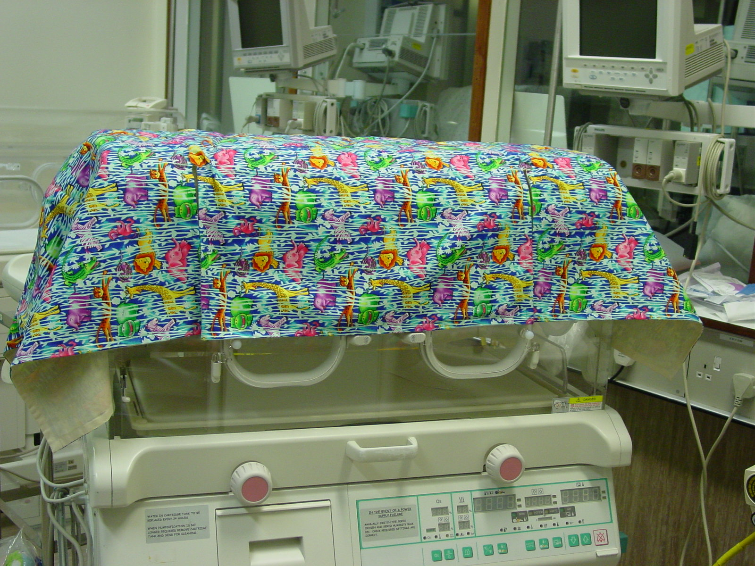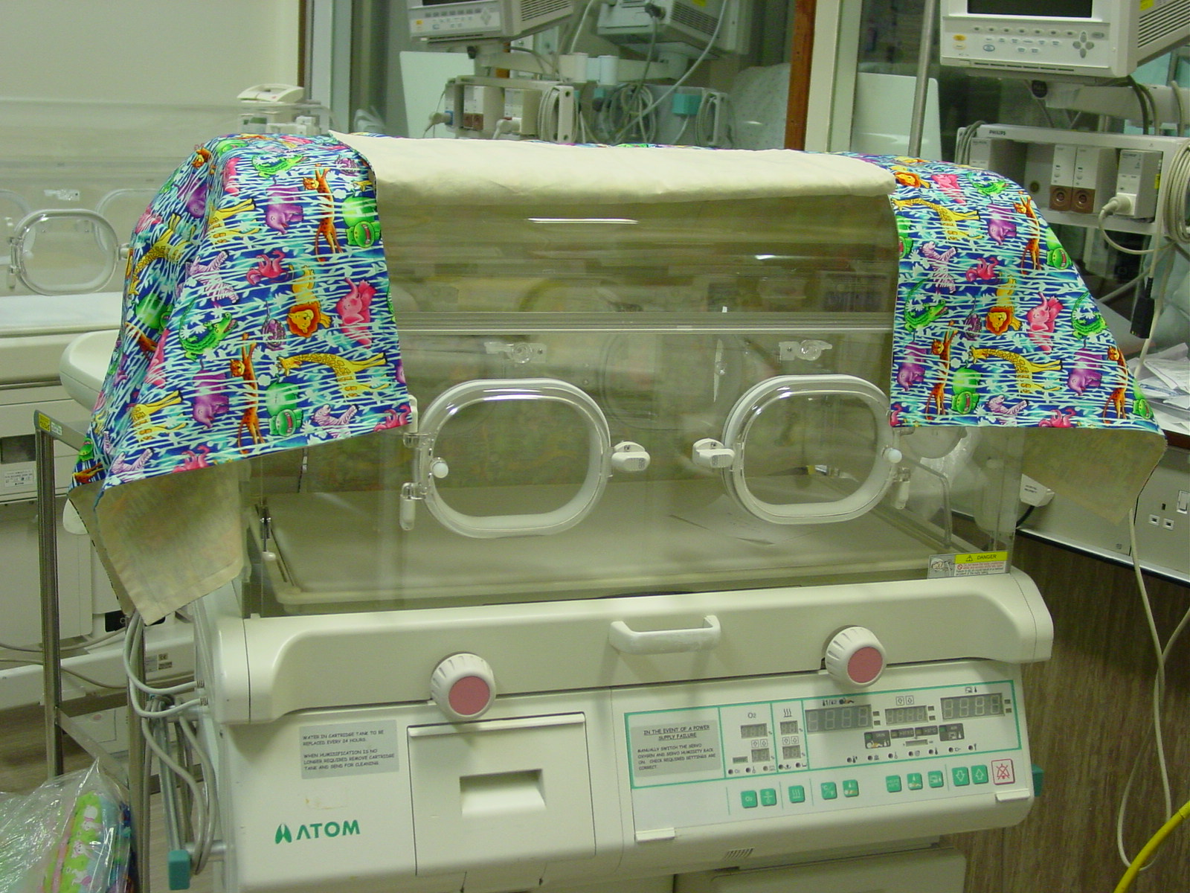

For those of you wanting to make a quilt but don’t have the time to make a big one then a ‘fat quarter’ quilt may be the thing for you. You can simply take two fat quarters, one of a child friendly patterned fabric to use as the top and a complimentary or contrasting one to use as a backing. Layer together with wadding and quilt – 2 lines across in each direction using a straight or fancy stitch is fine. Apply a binding to the edges and sew on a label. I often use the 2” strips from my stash for the binding – sometimes using different strips on each side. Job done as Jamie Oliver would say!!

If you’re feeling a bit more adventurous you can take any quilt block and super size it to a 20” square (or thereabouts) to make the top. Luckily children come in all sizes so you don’t need to be too worried about the final size!!

Tip: Set aside a single day and see how many you can make – I made eight – which meant there was 4m of fabric less in my stash.

Finally I wanted to say thank you to those of you that have sent stamps to help cover postage costs. Each issue of the newsletter costs approx £40 to issue - this includes paper, envelopes, printing ink and stamps – but I think it is a really important part of the job that I do as co-ordinator to keep in touch with you. However, if you would prefer not to receive future newsletters please let me know and I’ll remove you from my mailing list.

Till next time keep stitching and remember I love getting parcels through the post or phone calls saying ‘I have some quilts, when can I bring them round?’
Joy

PS: I have enclosed a label for you – just in case you need one.

